

Databases Assignment 2:
Internet Movie Database (IMDB.com)
Star Schema and ETL

DT228/4
BSc in Computer Science

Leslie Ducray
C10327999
20 December 2013

Introduction

The purpose of this document is to record the Extraction, Transformation and Loading process of two near identical ER schemas and integrating them into a Dimensional model. The Star model will be implemented from the IMDB ER and schema which was developed in Assignment 1.
The IMDB relational model has been duplicated, and both populated with data (some duplicated records). Attributes of the Celebrity, Title and User entity table has been altered to store different values
(celebrity, user) Gender: 0- female, 1-male, where originally stored ‘F’, ‘f’, ’M’ or ‘m’.
(Celebrity) Height: feet, where originally meters were stored.
(Title, user_rating) Rating: out of 100, where originally out of 10.
The two table entities are merged into a single staging table. All tables have been merged through staging, but only those relevant to the desired business process have been implementing through to the dimensional model.
The selected business process revolves around the rating system of IMDB, the fact table will hold references the associated score and five dimension tables:
- The User
- The Title
- The country of the user
- The age of the user
- The month/ year the title was rated.
- 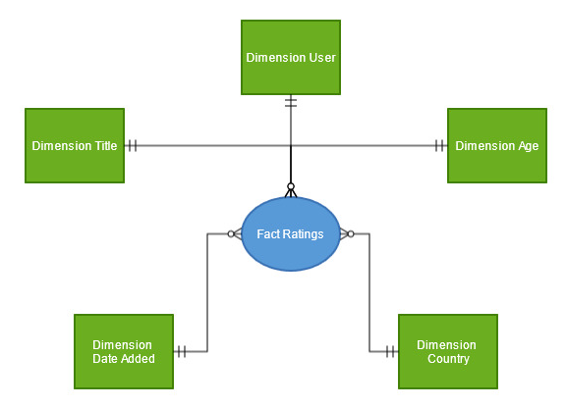
Figure 1: The Star Model

Staging
The ‘Stage_User’ and ‘Stage_Title’ are derived from the original ‘Users’ and ‘Title’ entities to form the staging tables for these entities. The records are extracted and merged, they are ‘cleaned’ to match, eg. The ‘Gender’ attribute to be consistent ‘m’ or ‘f’, the ‘rating’ attribute to be a score out of 10. The staging tables contain the original database sources, the records unique id’s from their respective tables and their new surrogate keys.
The ‘Stage_country’ table is the staging platform for all the countries. These countries are distinctly populated based on the counties of residence from both the user tables.
The ‘Stage_age’ entity is a table populated with the distinct ages of users that have rated a title.
If the user rates a title again, their previous result is not overwritten in the data warehouse, a new record is added. These can be used to query the correspondences between the rating of a title and the age of the user. Only ages of users who have rated a title are stored.
Finally, the ‘Stage_date_added’ table is populated with the distinct month-year values of each rating. The aim is that these may be used to enhance queries regarding ratings in relation to when the title was released or when the most ratings occur during the year.
The above tables form the five dimensions tables of the star model. The central fact_stage table, this table holds the records original id’s from their respective schemas/tables which are used to derive their new surrogate keys. The fact_stage also holds the user’s rating.
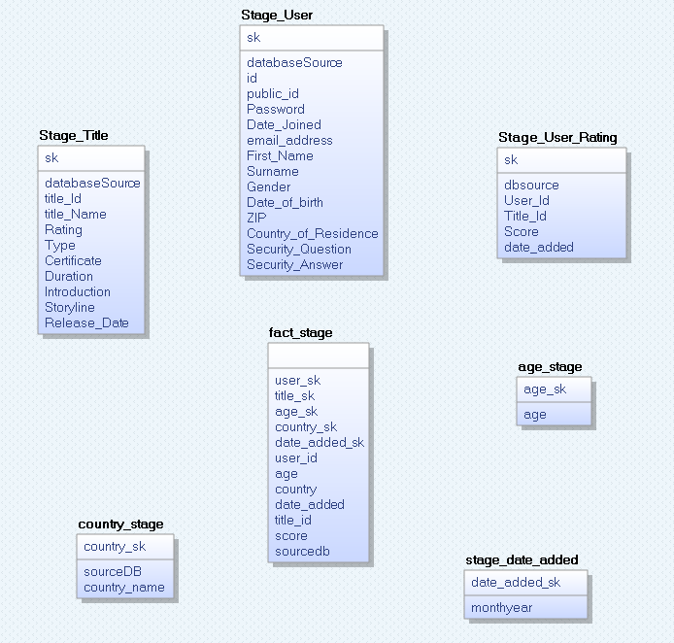
Figure 2: The staging tables

Load Dimensions
The dimension tables are populated by their corresponding staging table with certain values removed. The records original database source and its original id are not inserted into the dimension table.
Only the dimension surrogate keys and the user score is inserted into the fact_table. These values are collaboratively used as the records key.
The grain for this fact table is a single vote from a single user on a single title. The age of the user, the country of the user and date the rating was made is stored with in this to define the record further.
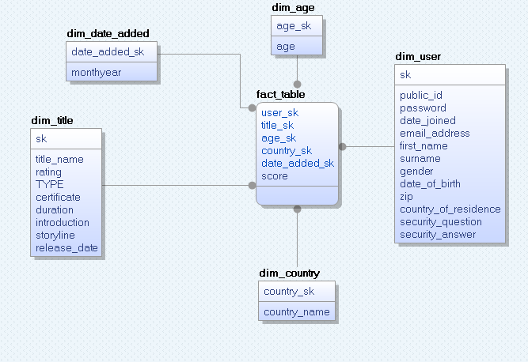
Figure 3: The final star model

ETL 2 and Beyond

Validation and constraints are incorporated to ensure that duplicate data is not inserted into the staging tables once the ETL is initiated after the initial ETL.
The validation ensures that the record from the original database is not already inserted into the staging tables therefor removing the possibility of duplicate records.

Script Order
- IMDB.sql
- Imdb_inserts.sql
- Staging.sql
- Dimension.sql
- ETL2.sql

